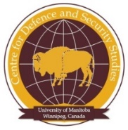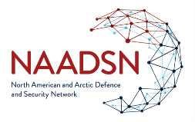

The Permanent Joint Board on Defense: How Permanent and Joint?
17 January 2020
Johns Hopkins University SAIS / Kennedy-Herter Auditorium
1740 Massachusetts Ave, NW
Washington, DC 20036
Davos-Style

Sponsored by the North American and Arctic Defence and Security Network, the School of Advance and International Studies, the University of Manitoba’s Centre for Defence and Security Studies and Institute for Humanities, and the Canadian Defence and Security Network

8:30 – 9:00 Continental breakfast and networking

9:00 – 9:30 Introductions

9:30 - 10:00 - Welcome

10:00 – 11:30 – PJBD in historic context

11:30– 12:30 Lunch and cake cutting
12:30 – 14:00 – PJBD Current Priorities

14:00 – 14:15 Health Break

14:15 – 15h30 – Future for PJBD

15h30 – 16:00 Thank yous and wrap up

